**Birding Sandy Mush**

Sandy Mush Game Land is a state owned 2679 acre tract that is actively managed with prescribed fire to provide quality early successional habitat through native habitat restoration. This area is home to several of North Carolina’s Priority Bird Species

The Bear Creek Road Access enters a clear-cut habitat offering the birder an opportunity to see Prairie and Blue-winged Warblers, Yellow-breasted Chats, Northern Bobwhite and Yellow-billed Cuckoos and White-eyed Vireo. Walk the main dirt road towards Sandy Mush Creek and enter a deciduous forest of singing Wood Thrush, Acadian Flycatcher, Louisiana Waterthrush, and Scarlet Tanagers.

The Cedar Hill Road Access allows for easy ridge top walking through forest and fields where Indigo Bunting, Field Sparrow and Northern Parula may be observed. In the kiosk parking lot located across from the Cedar Hill Baptist Church, Orchard Oriole may be seen in the nearby trees. The brushy habitat with mixed food plots below the kiosk is a good area to view wintering Sparrows such as White-crowned, White-throated, Fox, Song, Field, and Swamp. Listen for Grasshopper Sparrows, Eastern Kingbird and Eastern Meadowlark in the big hayfields near the fork of Cedar Hill Rd and Old SR 20.

The Martin Candler Access has numerous planted fields and good scrub-shrub habitat. Yellow-breasted Chats, Blue Grosbeaks, American Kestrels, Eastern Bluebird, Brown-headed Nuthatch, and numerous wintering Sparrows and Finches can be seen here.

The Old SR 20 Access has many of the same birds seen elsewhere. However, the Wild Turkey and Ruffed Grouse can be heard in spring, while an encounter with the Wood Duck along Turkey Creek is a good possibility.

The following list contains 153 species of birds observed by NCWRC biologists and Elisha Mitchell Audubon Society members since 2005. Some species were observed on land adjacent to the game land. Bird data for the game land is incomplete, and the checklist may not contain all credible sightings. We encourage birders to report anysightings of birds, butterflies, dragonflies or any other wildlife on the Elisha Mitchell Audubon Society’s web page @ [www.emasnc.org](http://www.emasnc.org) Under “Local Wildlife Sightings” submit to [emas@freelists.org](mailto:emas@freelists.org)

Put Sandy Mush Game Land in the Subject heading.

**Seasonal Occurrences & Relative Abundance**

**(in suitable habitat)**

**S -Spring** March-May

**s –Summer** June-August

**F –Fall** Sept-November

**W-Winter** December-February

**C-Common**: Seen regularly in suitable habitat

**F-Fairly Common:** Likely to be seen in suitable habitat

**U-Uncommon**: Present, but may not be seen

**O-Occasional:** Seen only a few times during a season

**R-Rare**: Not seen every year

A- Accidental: Seen only once.

**Ducks, Geese and Swans S s F W**

Canada Goose F F F F

Wood Duck F F F F

Mallard O O O O

_____Blue-winged Teal R

Hooded Merganser R

**Game Birds**

_____Northern Bobwhite C C C C

_____Ruffed Grouse C C C C

_____Wild Turkey C C C C

**Loons**

_____Common loon R

**Cormorants**

_____Double-crested cormorant R R

**Bitterns, Herons and Allies**

_____Great Blue Heron F F F F

_____Great Egret R

_____Green Heron U

**Vultures, Hawks, Eagles and Allies**

**_____**Black Vulture C C C C

_____Turkey Vulture C C C C

_____Swallow-tailed Kite A

_____Osprey U O O

_____Bald Eagle R R

_____Northern Harrier U U U

_____Sharp-shinned Hawk F F F F

_____Cooper’s Hawk F F F F

_____Red-shouldered Hawk F F F F

_____Broad-winged Hawk F F F

_____Red-tailed Hawk C C C C

**_____**American Kestrel C C C C

_____Peregrine Falcon R

**S s F W**

**Cranes and Rails**

_____Sandhill crane R R

**Sandpipers, Phalaropes and Allies**

**_____**Spotted Sandpiper O O

_____Solitary Sandpiper R R

_____Upland Sandpiper R

_____Wilson’s Snipe U

_____American Woodcock U U U U

**Pigeons and Doves**

**_____**Rock Pigeon R R

**_____**Mourning Dove C C C C

**Cuckoos**

**_____**Yellow-Billed Cuckoo C C C

**Barn Owls and Typical Owls**

**_____**Barn Owl U U U U

_____Eastern Screech Owl C C F U

_____Great Horned Owl F F F F

_____Barred Owl F F F F

**Goatsuckers**

**_____**Eastern Whip-poor-will F U

**Swifts and Hummingbirds**

**_____**Chimney Swift C C C

**_____**Ruby-throated Hummingbird C C C

**Kingfishers and Woodpeckers**

**_____**Belted Kingfisher C C C

**_____**Red-headed Woodpecker R R

_____Red-bellied Woodpecker C C C C

_____Yellow-bellied Sapsucker C C C

_____Downy Woodpecker C C C C

_____Hairy Woodpecker F F F F

_____Northern Flicker C C C C

_____Pileated Woodpecker C C C C

**Tyrant Flycatchers**

**_____**Eastern Wood-pewee F F

_____Acadian Flycatcher C C

_____Willow Flycatcher R

_____Eastern Phoebe C C C C

_____Great Crested Flycatcher F F

_____Eastern Kingbird F F

**Vireos**

**_____**White-eyed Vireo C C C

_____Yellow-throated Vireo U U

**S s F W**

_____Blue-headed Vireo F F F

_____Red-eyed Vireo C C C

**Jays and Crows**

**_____**Blue Jay C C C C

_____American Crow C C C C

_____Common Raven O O O

**Swallows**

**_____**Purple Martin R O

**_____**Tree Swallow F F

_____Northern Rough-winged SwallowF F

**_____**Bank Swallow R

_____Cliff Swallow R

_____Barn Swallow F F

**Chickadees and Titmice**

_____Carolina Chickadee C C C C

_____Tufted Titmouse C C C C

**Nuthatches**

_____Red-breasted Nuthatch U U U

_____White-breasted Nuthatch C C C C

_____Brown-headed Nuthatch F F F F

**Creepers**

**_**____Brown Creeper U U U

**Wrens**

_____Carolina Wren C C C C

_____House Wren U F U

_____Winter Wren U R U U

_____Marsh Wren R

**Gnatcatchers and Kinglets**

_____Blue-gray Gnatcatcher C C C

_____Golden-crowned Kinglet F F F

_____Ruby-crowned Kinglet U U U

**Thrushes**

_____Eastern Bluebird C C C C

_____Gray-cheeked Thrush R

_____Swainson’s Thrush F

____Hermit Thrush U U U

____Wood Thrush F F U

____American Robin C C C C

**Mockingbirds and Thrashers**

____Gray Catbird F C F

____Northern Mockingbird C C C C

**S s F W**

____Brown Thrasher F F U U

**Starlings**

____European Starling C C C C

**Wagtails and Pipits**

____American Pipits R

**Waxwings**

_____Cedar Waxwing C C C F

**Wood-Warblers**

_____Ovenbird C C

_____Worm-eating Warbler F F

_____Louisiana Waterthrush F F

_____Blue-winged Warbler U U

_____Black-and-white Warbler F F

_____Tennessee Warbler F

_____Orange-crowned Warbler R

_____Nashville Warbler O

_____Kentucky Warbler O O

_____Common Yellowthroat C C F

_____Hooded Warbler C C F

_____American Redstart U U F

_____Cape May Warbler R

_____Northern Parula C C F

_____Magnolia Warbler U

_____Blackburnian Warbler O O

_____Yellow Warbler O

_____Blackpoll Warbler U

_____Black-throated Blue Warbler U

_____Palm Warbler F

_____Pine Warbler F F U U

_____Chestnut-sided Warbler F

_____Yellow-rumped Warbler F F F

_____Yellow-throated Warbler F F

_____Prairie Warbler C C

_____Black-throated Green Warbler F F

_____Yellow-breasted Chat C C

**Towhees and Sparrows**

_____Eastern Towhee C C C C

_____Chipping Sparrow F F F U

_____Field Sparrow C C C C

_____Savannah Sparrow U U U

_____Grasshopper Sparrow F F O

_____Fox Sparrow R U U

_____Song Sparrow C C C C

_____Swamp Sparrow U U F

_____White-throated Sparrow C C C

**S s F W**

_____White-crowned Sparrow C C C

_____Dark-eyed Junco C C C

_____Vesper Sparrow O

_____Clay-colored Sparrow R

_____Lincoln’s Sparrow O

**Cardinal, Tanagers and Allies S s F W**

_____Summer Tanager R

_____Scarlet Tanager F F F

_____Northern Cardinal C C C C

_____Rose-Breasted Grosbeak F

_____Blue Grosbeak F F

_____Indigo Bunting C C C

**Blackbirds and Orioles**

_____Red-winged Blackbird F F F F

_____Eastern Meadowlark F F F F

_____Rusty Blackbird R R

_____Common Grackle U U

_____Brown-headed Cowbird F F

_____Orchard Oriole U U

_____Baltimore Oriole O O

**Finches and Allies**

_____Purple Finch O O O

_____House Finch U U U U

_____Red Crossbill R R R

_____Pine Siskin O O O

_____American Goldfinch C C C C

**Notes**

**Observer(s):** ___________________________________

______________________________________________

**Date:____________ Start/End Times:_______/_______**

**Weather Conditions: ___________________________**

**Observation Type:** Stationary or Traveling

**Distance Traveled: ______________________________**

**Location: _____________________________________ ______________________________________________**

**No. of Species: _________________________________**

**Remarks:____________________________________________________________________________________**

 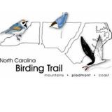

[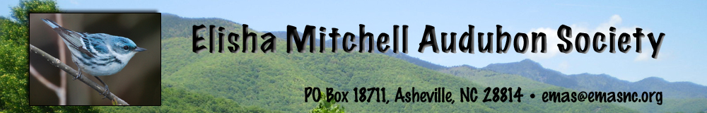](http://emasnc.org/index.html)

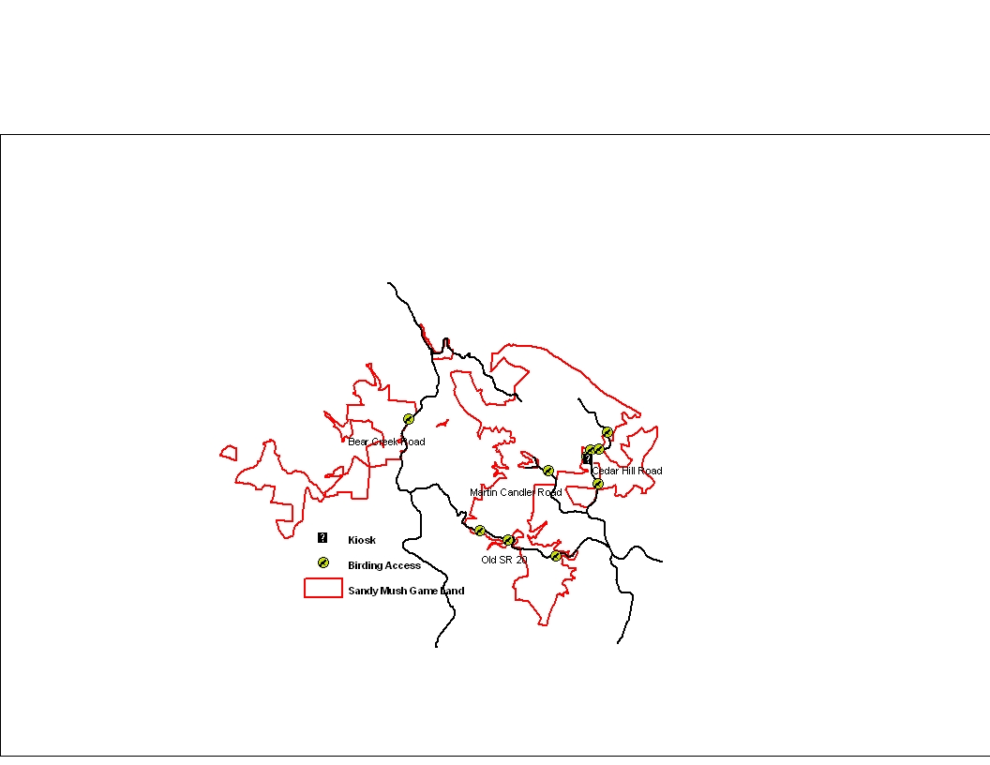

**Special Note**

Additional info can be obtained from the NCWRC website @ ncwildlife.org, NC Birding Trail @ncbirdingtrail.org and Elisha Mitchell Audubon Society @ emasnc.org or stop by the Sandy Mush Game Land Information Kiosk located across from the Cedar Hill Baptist Church on Cedar Hill Road (35°43′18.391N, 82°39′46.795W). Directions for the access points are available @ emasnc.org/ Revised 1/8/2013

**BIRDS**

**of**

**SANDY MUSH**

**GAME LANDS**

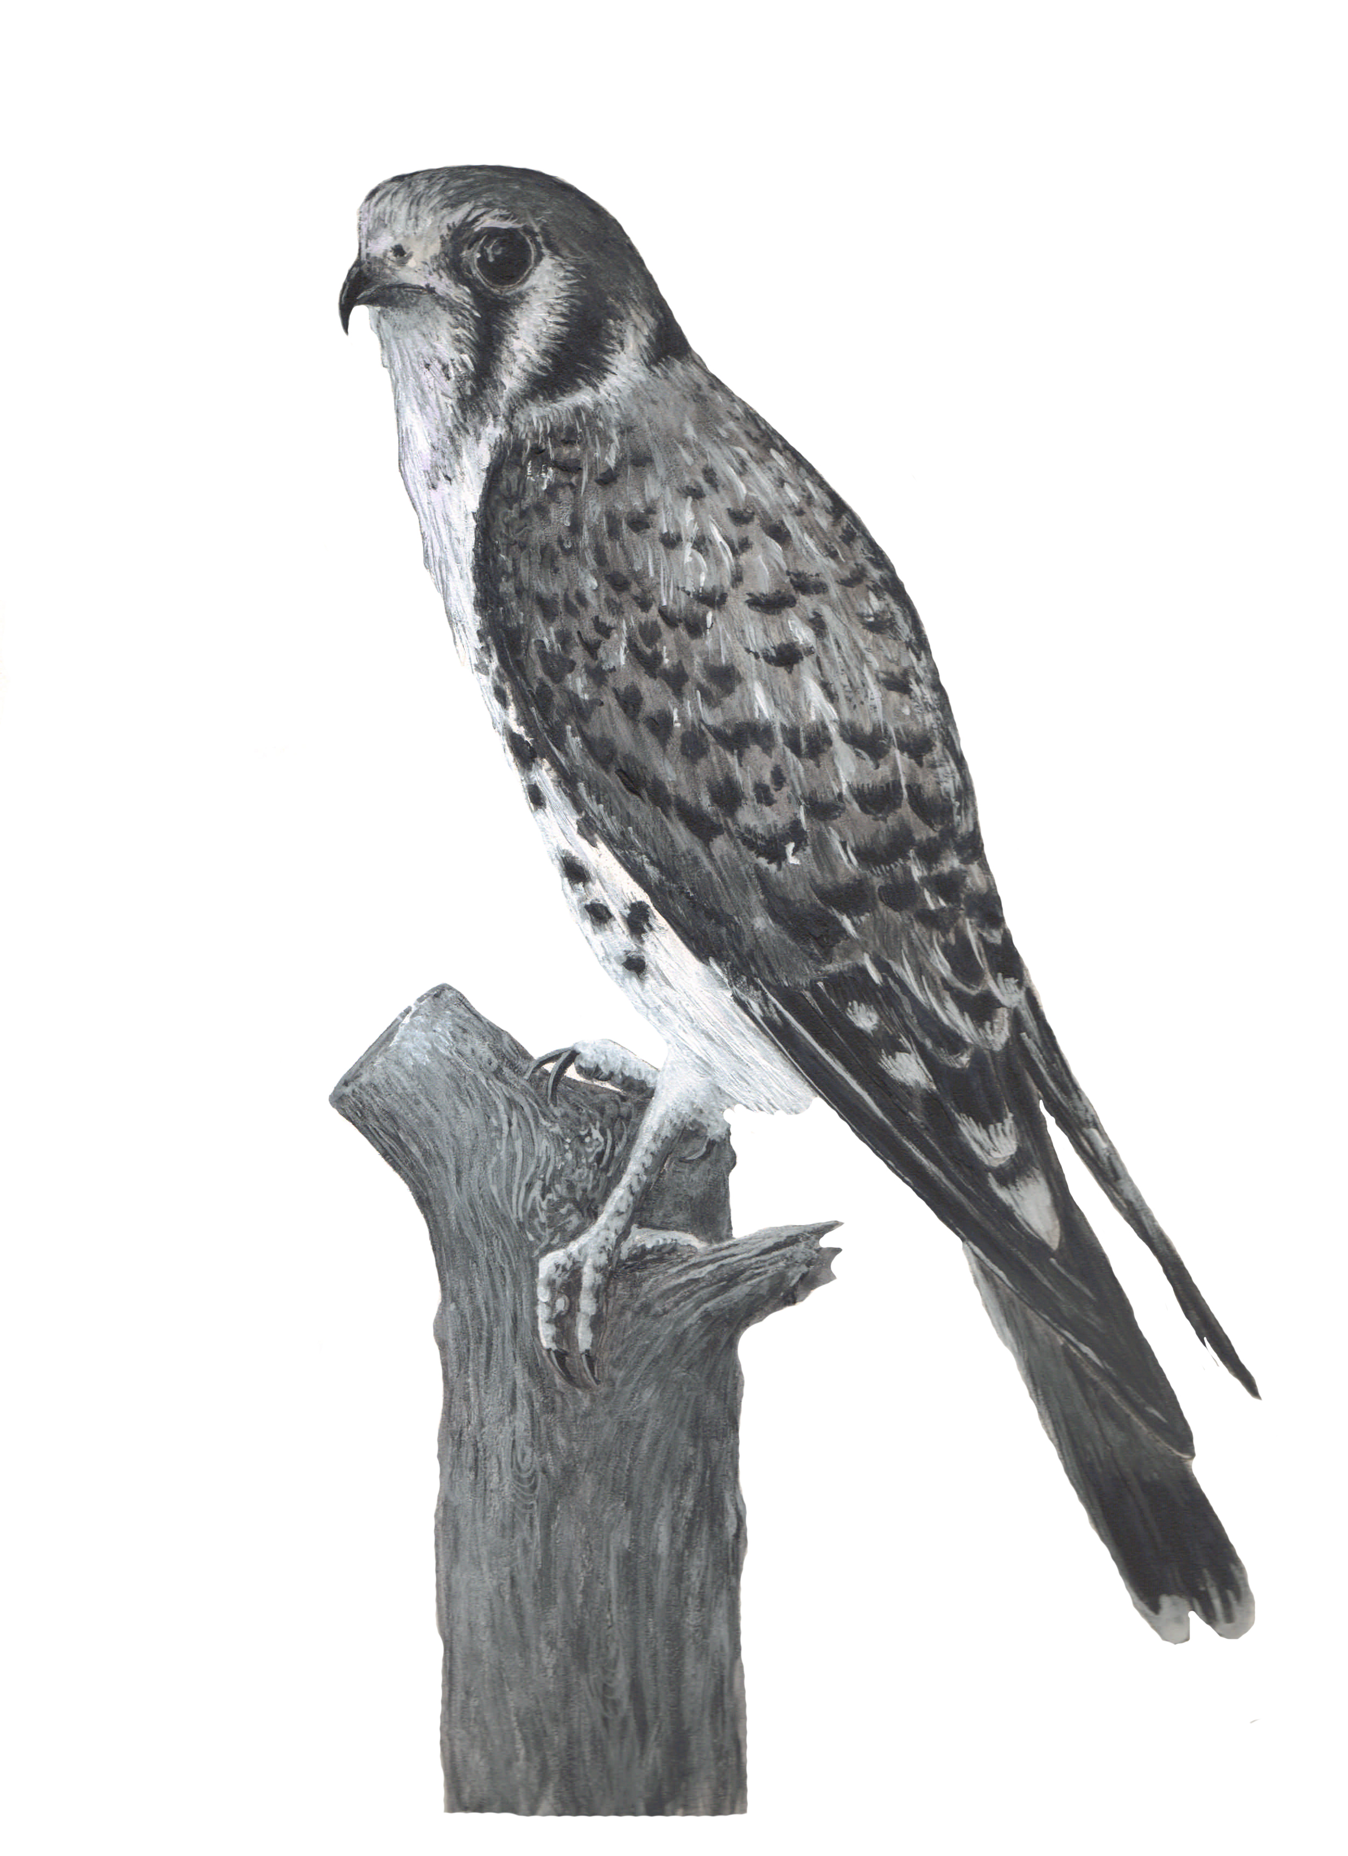

Illustration by Paul Thompson

12/23/10